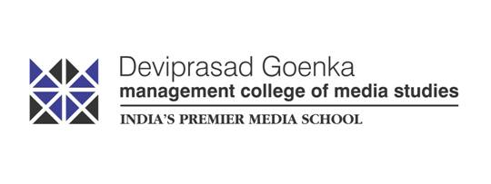

**Deviprasad Goenka Management College of Media Studies (DGMC)**

**RSET Campus, S. V. Road, Malad (w), Mumbai 400 064, Maharashtra, India**

Notice: 363/2021 19 March 2021

**NOTICE**

**MOCK TEST**

**MA FTNMP / MA CJ REGULAR-Semester I Examination**

A Mock Test for **Regular – SEM I** shall be held on 22nd March 2021from **11am to 12 noon**. The said examination is in the form of Multiple Choice Questions (**MCQ**) where a student is required to attempt a minimum of 40 Questions out of the 50 Questions that shall be asked to the students.

The said Mock Test is exactly in line with the Semester End Examination.

Students will receive the **URL**, **Login ID** and **PASSWORD** via email and SMS. Students are requested to check their emails / SMS for the same.

**It is mandatory for all students to appear for the Mock Test.**

In case of any issue please get in touch with the Admin Office.

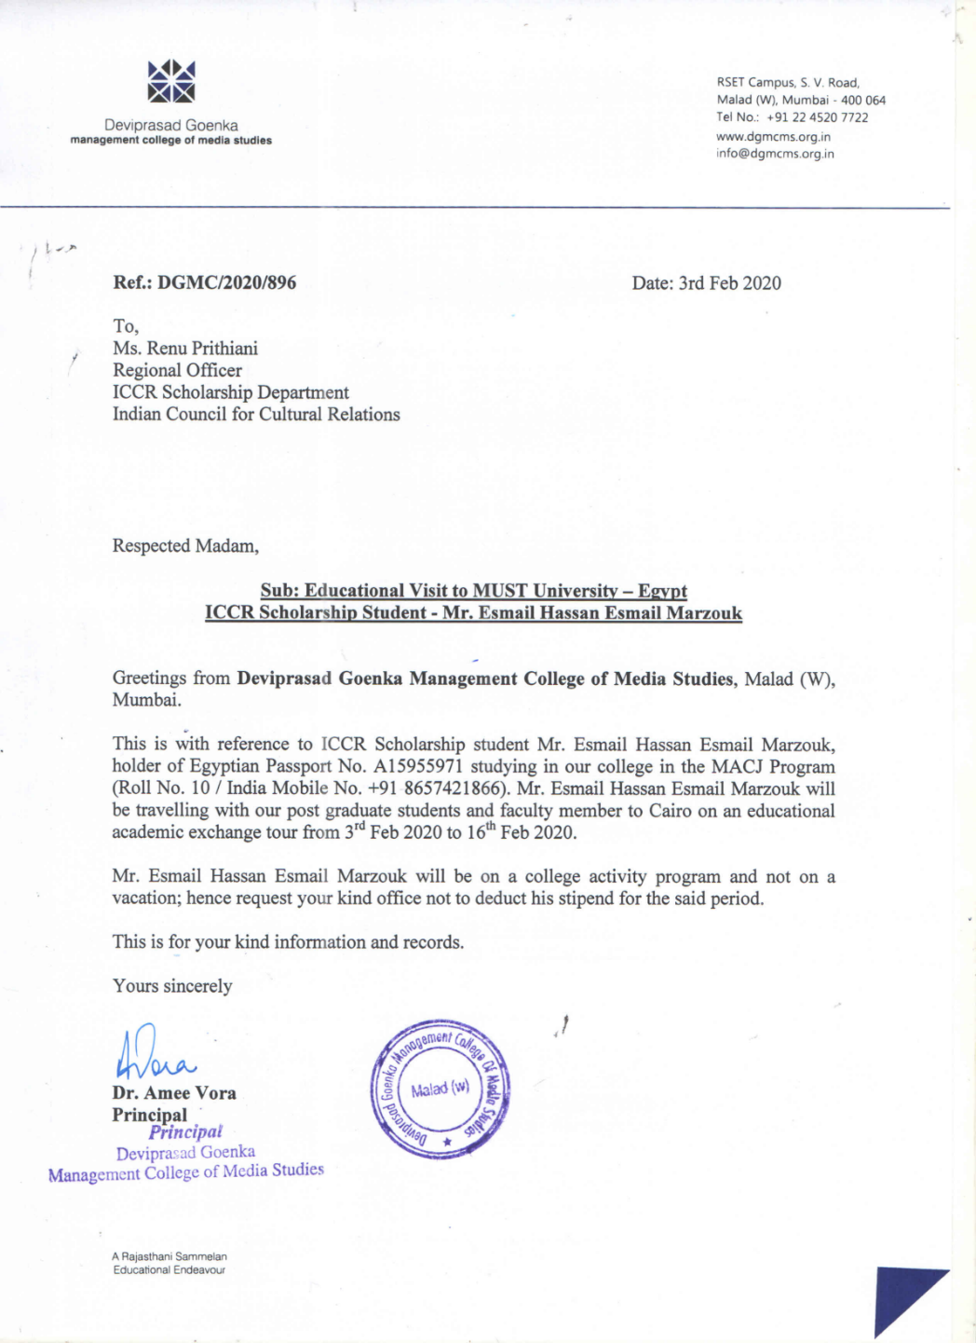

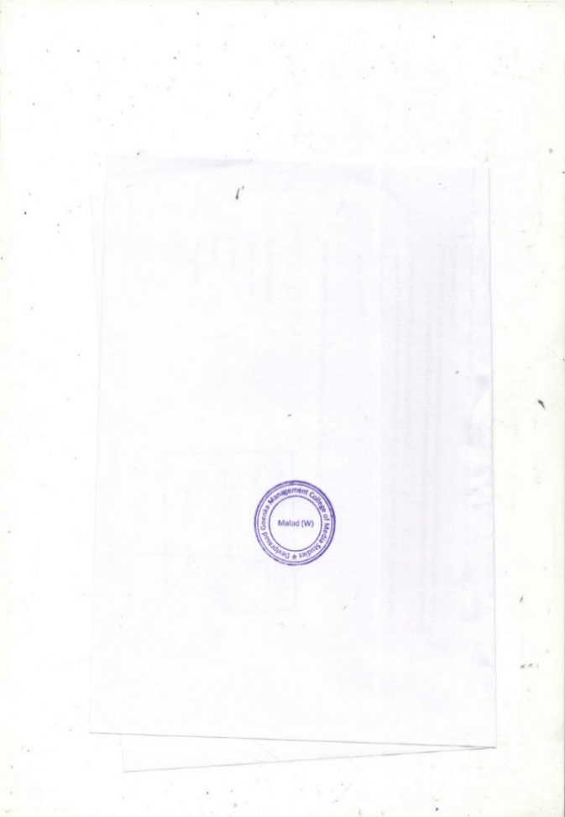

**Dr. Amee Vora**

Principal